Department of Botany
Guest Lecturers
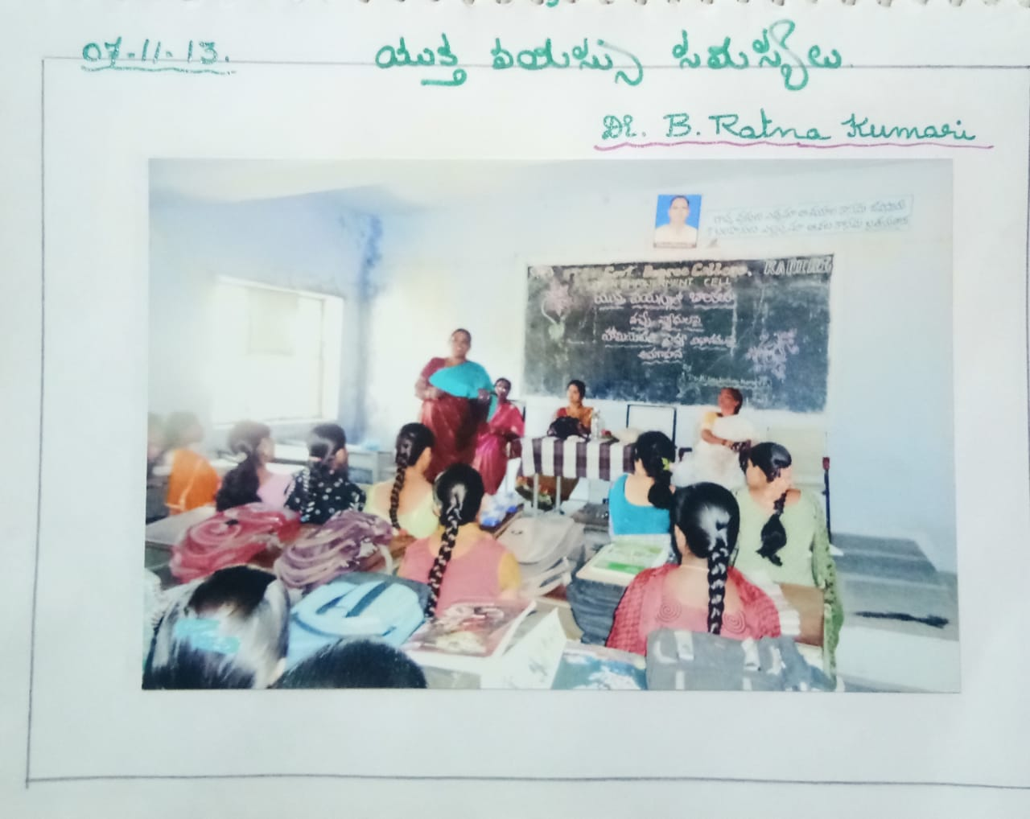

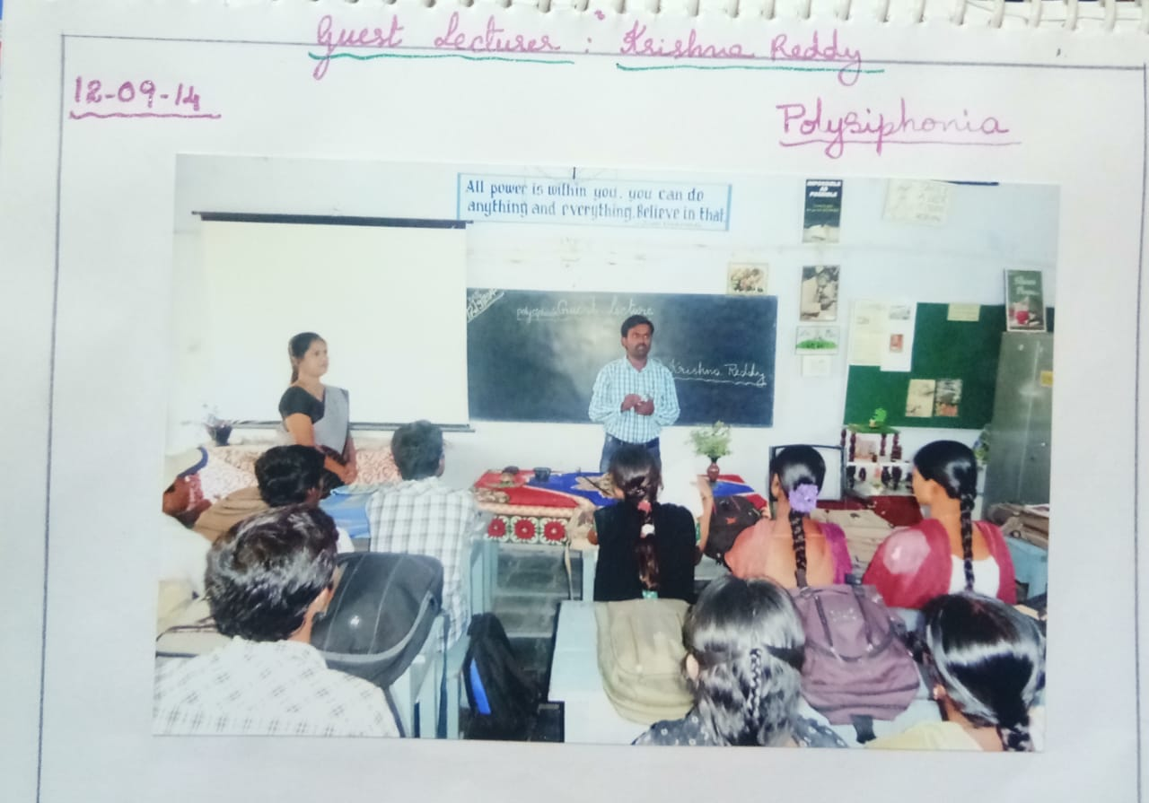
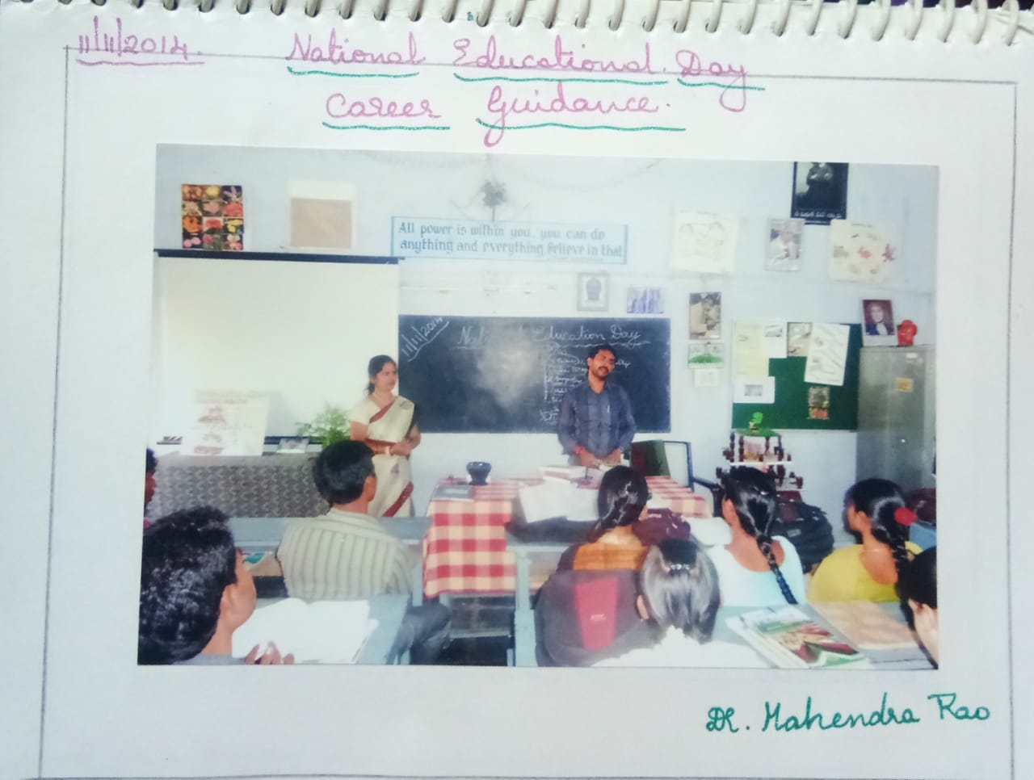

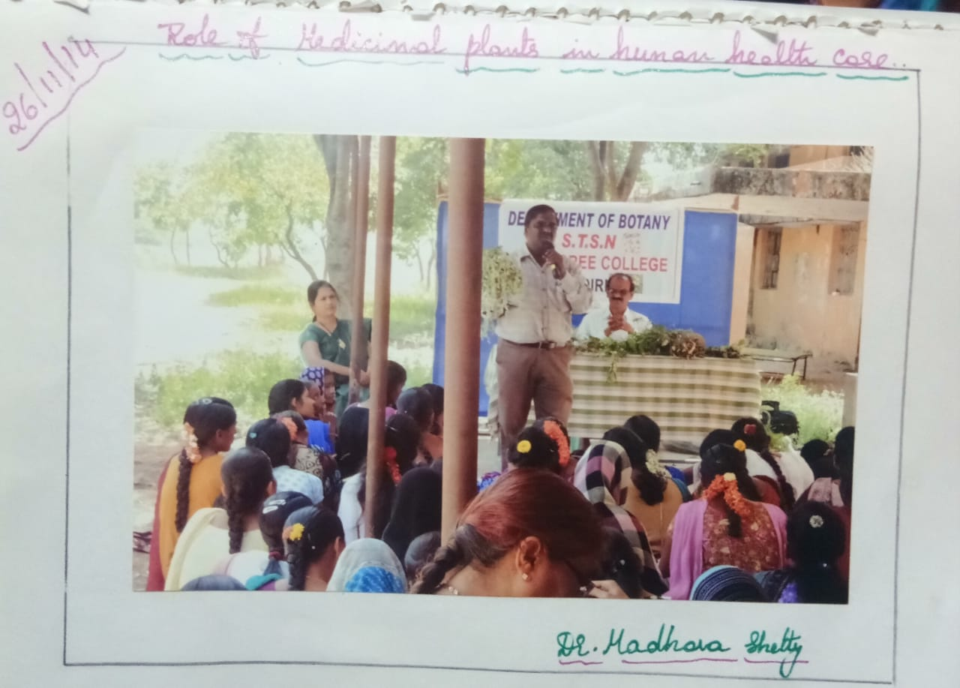

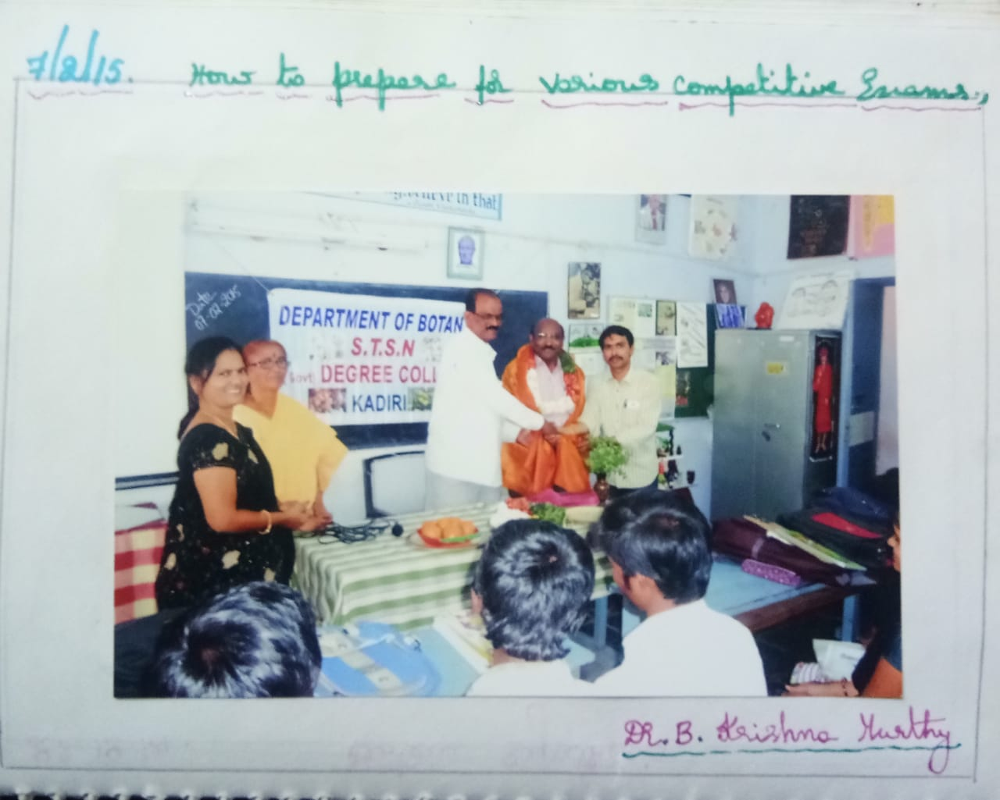

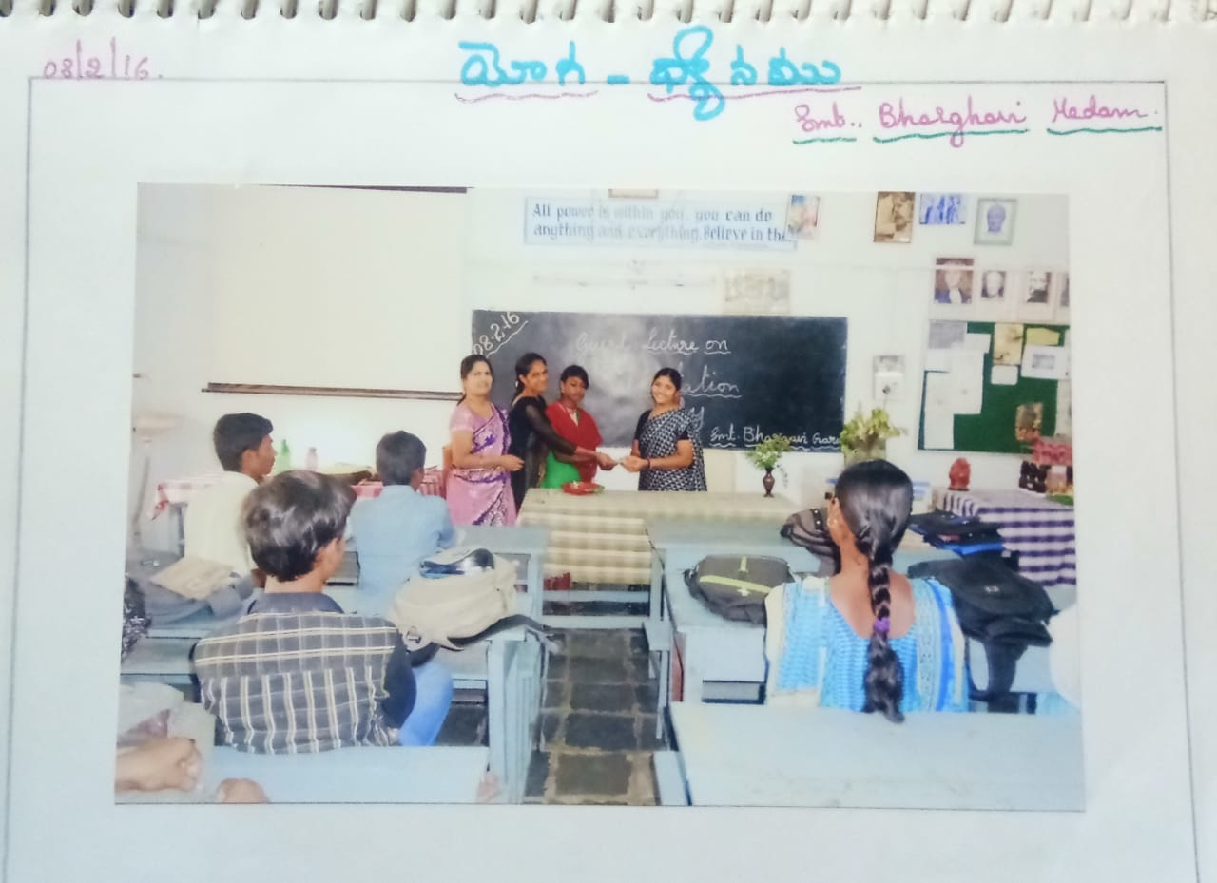
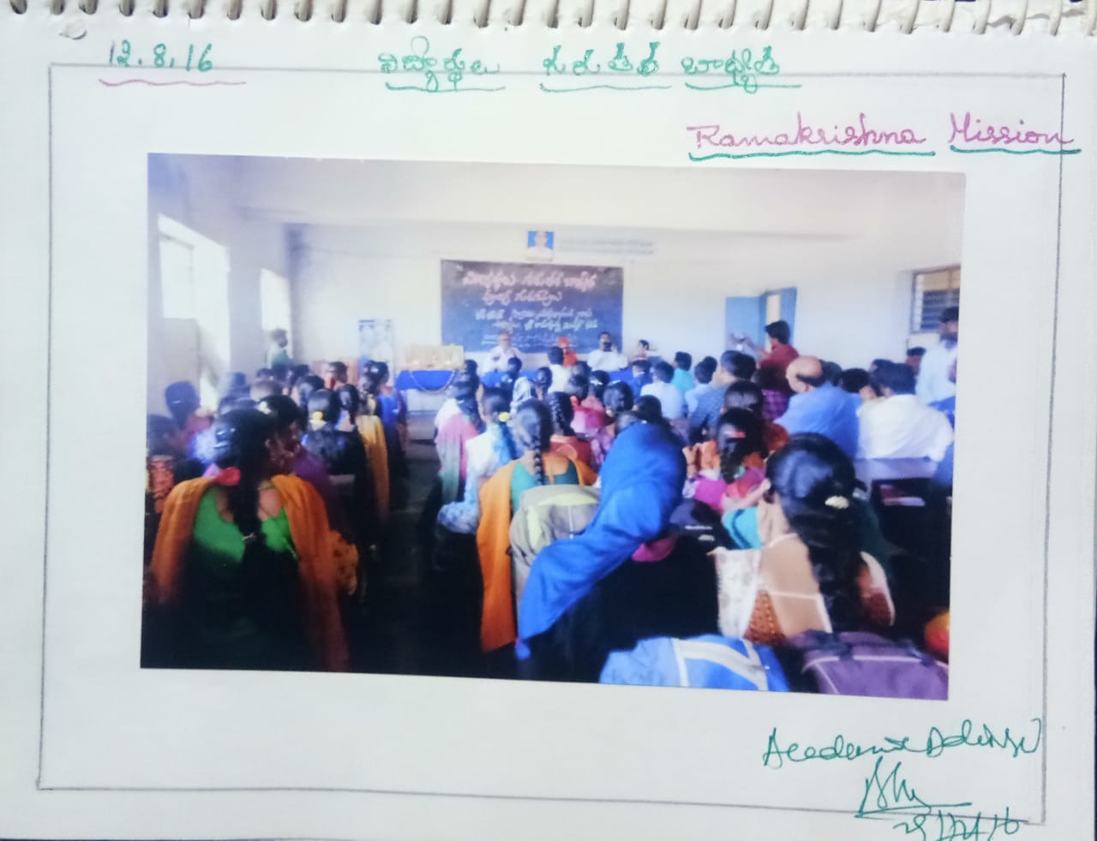
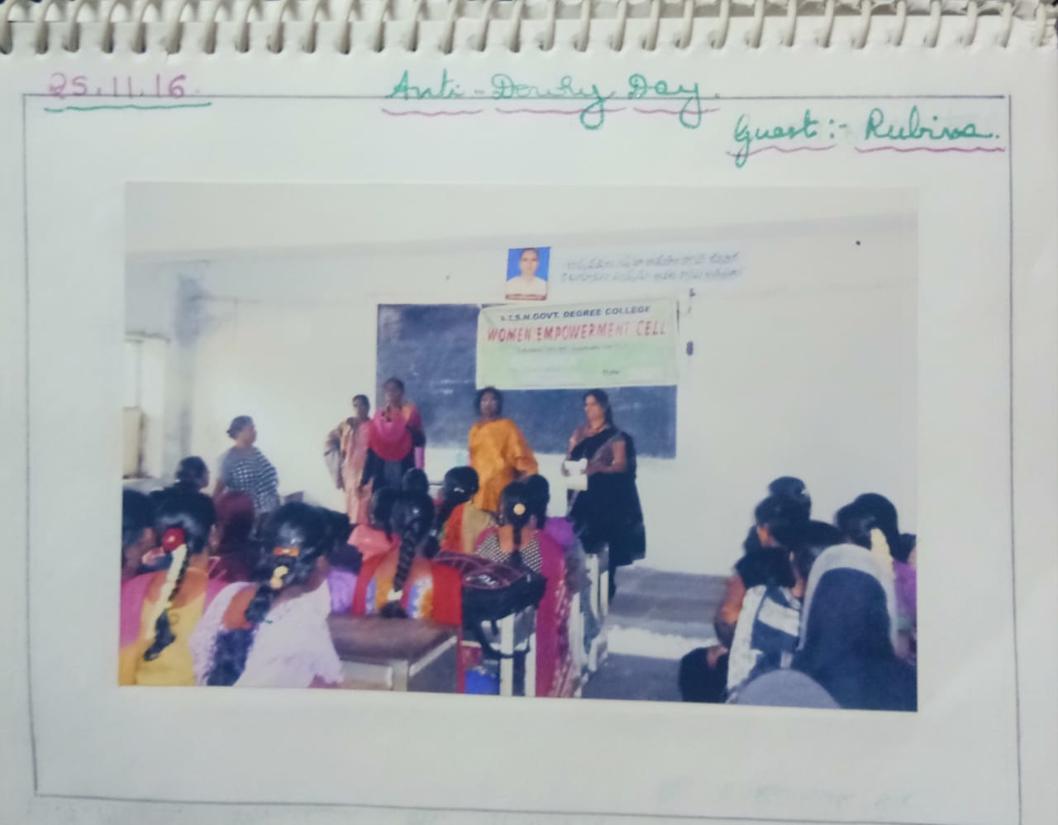
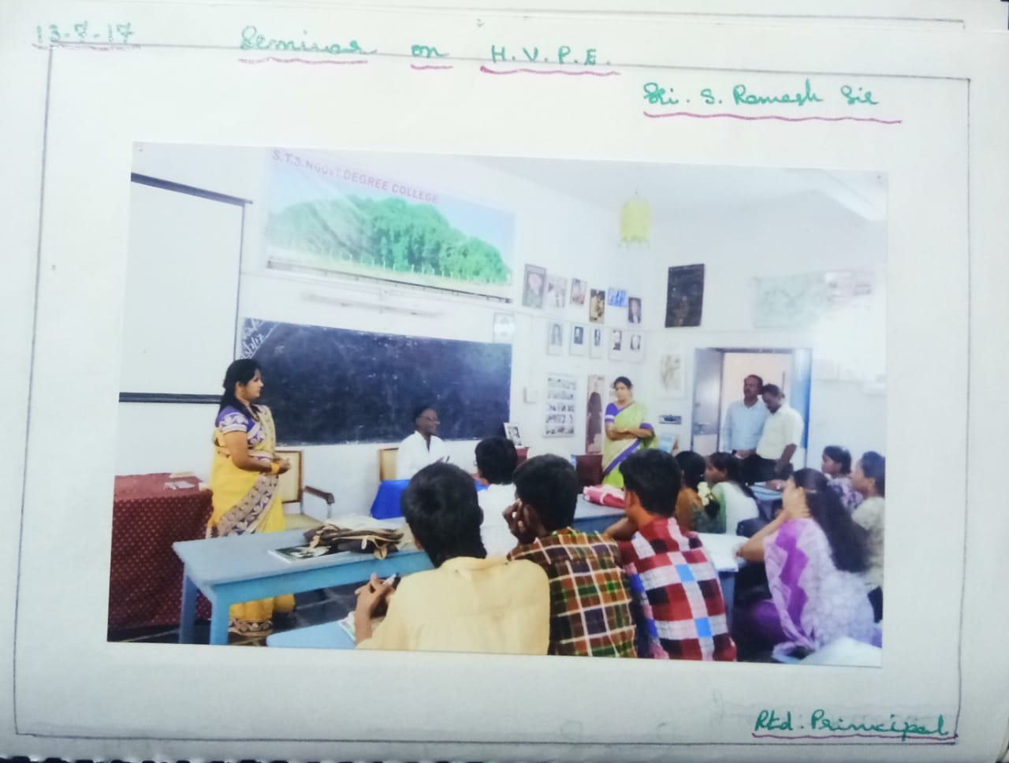
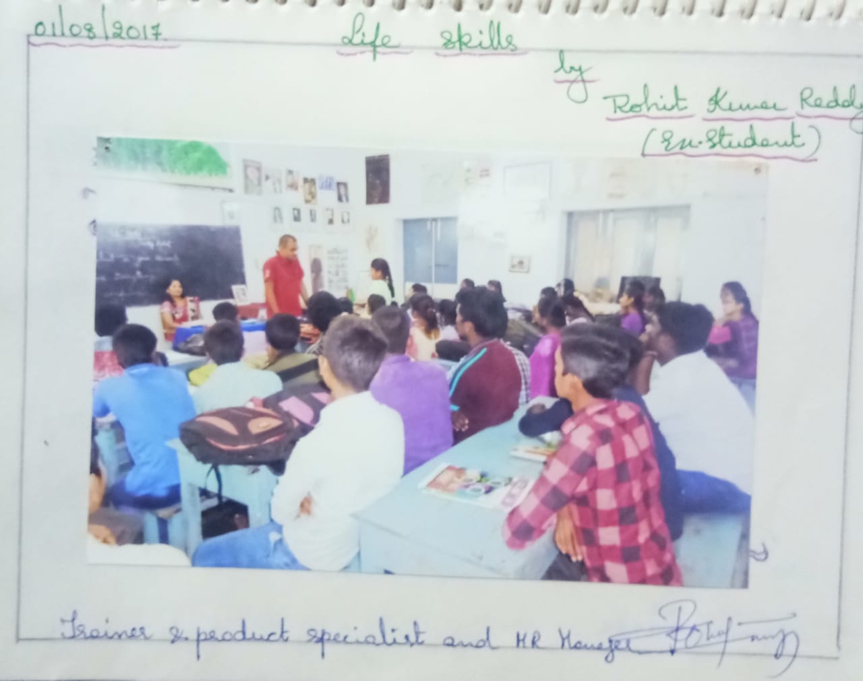
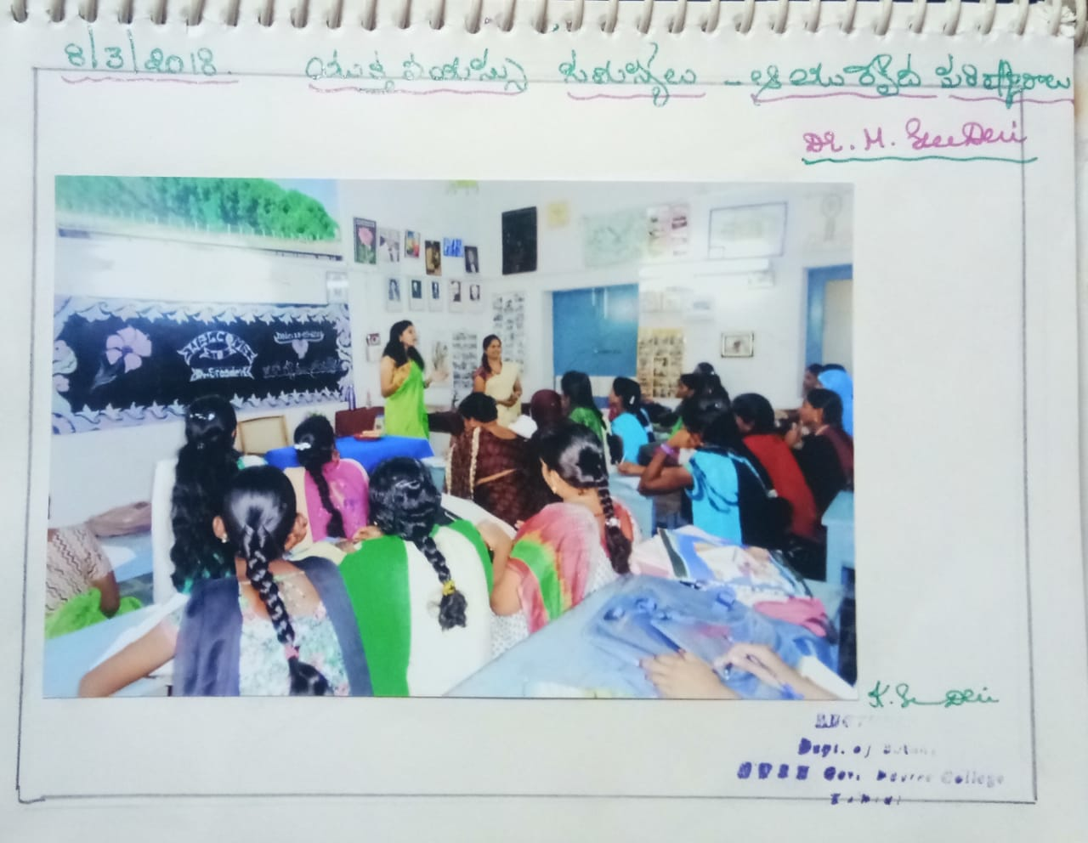
S.NO | NAME OF THR GUEST | DATE | TOPIC
1 | Dr.B.RATNA KUMARI | 07/11/2013 | SOLUTIONS TO TEENAGE PROBLEMS
2 | K.KRISHNA REDDY | 12/09/2014 | POLYSIPHONIA
3 | Dr.MAHENDRA RAO | 11/11/2014 | CAREER GUIDANCE
4 | Dr.MADHAVA SHETTY | 26/11/2014 | ROLE OF MEDICINEL PLANTS IN HUMAN HEALTH CARE
5 | Dr.B.KRISHNAMURTHY | 07/02/2015 | HOW TO PREPARE FOR VERIOUS COMPETITIVE EXAMS
6 | Smt.M.BHARGAVI | 08/02/2016 | YOGA--MEDITATION
7 | RAMAKRISHNA MISHION | 12/08/2016 | STUDENTS RESPONSIBILITY
8 | RUBINA | 25/11/2016 | ANTI—DOWRY DAY
9 | Sri.S.RAMESH SIR | 13/07/2017 | H.V.P.E.
10 | ROHIT KUMAR REDDY | 01/08/2017 | LIFE SKILLS
11 | Dr.M.SREE DEVI | 08/03/2018 | AYURVEDIC SOLUTIONS FOR TEENAGE PROBLEMS

